**A comparative analysis on the prospect of Geothermal and Wind energy in Bangladesh anddiscuss how the addition of these renewable sources can help to achieve 10% share of renewable energy in electricity generation in Bangladesh by the year 2025**

SOURAV DAS, ID: 18-37400-1-1, Email: [sdhriday77@gmail.com](mailto:sdhriday77@gmail.com),   
Department of Electrical and Electronic Engineering, American International University-Bangladesh (AIUB) 408/1, Kuratoli, Khilkhet, Dhaka 1229, Bangladesh

*Abstract*— A green source of energy is requiring for to complete the energy requirement as the conventional sources are limiting day by day. As Bangladesh is a developing country and we all know power is the most important factor for a development country. All things are getting digitalized day by day. We need more power, for this there must be a great shortage of power failure occur. Mainly this shortage of power occurs due to several reason like high rate of fossil or fissile fuel, low generation capacity, high demand etc. For to overcome this crisis we need some energy sources like green renewable based energy sources.  In the present situation there is no option of environmentally friendly power and Bangladesh have an extraordinary chance to produce power from geothermal energy to conquer this force emergency. North-east locale of this nation is appropriate for planting geothermal force plant. The geothermal slope at south-east locale changes from 19.8 to 29.5°C/km along the northwest 20.8 to 48.7°C/km [1]. As they are cost efficient and environment friendly, that’s why everyone is shifting towards to this green energy sources. More of less this green energy sources will be the great source to solve this power shortage crisis. Mainly in this paper Geothermal and Wind based emery been discuss and how to achieve 10% share of renewable energy in electricity generation in Bangladesh by the year 2015.

Keywords- green energy, cost-efficient,

# Introduction

Energy is fundamental for our general public to guarantee our personal satisfaction furthermore, to support any remaining components of our economy. Sustainable power innovations offer the guarantee of spotless, plentiful energy assembled from self-reestablishing assets like the sun, wind, earth also plants. There are different kinds of green energy like wind, solar, biomass, and geothermal and all of these green technologies are cost-effective today in an increasing number of markets, and are making important steps to broader commercialization. As the specialized status, cost, and utilizations of major sustainable power advancements and suggestions for expanded reception of renewables will be surveyed. Geothermal and Wind energy are most common renewable energy sources. As our population is increasing day by day, our conventional energy sources are not enough to supply as the load demand. On the other hand, we have limited resources like fossil and fissile fuel. In this case we must have to shifted in those green energy sources. As we all know Bangladesh is an overpopulated country and we are mainly depending of Hydro and Gas power station. As the resources are limited, those gas-based power stations are not sufficient enough for to fulfill our energy depend. On the other hand, operation cost of those power plants is huge in our country’s perspective. Beside those they not much ecofriendly. As those are our enormous energy assets, we need to move in green power sources gradually. Wind energy has a large share in renewable energy sectors which cut a large share on fossil fuel demand. As compare to other non-renewable based power plants these green energy sources are very much cost efficient. Renewables made up more than 17 percent of net U.S. electricity generation in 2018, with the bulk coming from wind power 6.6 percent. Eighteen percent of the energy consumed globally for heating, power, and transportation was from renewable sources in 2017. Nearly 60 percent came from modern renewables i.e., biomass, geothermal, solar, hydro, wind, and biofuels. But in our country’s perspective, this share is much lesser then other developing countries.

# Energy Demand in Bangladesh

The Ministry of Power, Energy and Mineral Resources cites that with a 160 million populace Bangladesh government gives power to 70% of individuals in 2015 and at present for each capita energy age 372 kWh while 75 the world all out Primary Energy Consumption per Capita 75 which is comparable to 21980.33025 kWh; this utilization is a lot more prominent than per capita energy utilization in Bangladesh. Bangladesh creates its greatest power from public lattice gas supply which is practically 62.31 % and petroleum Bangla reports that Bangladesh power age to a great extent relies upon 80% on gas. Subsequently the most extreme creation of power being controlled by nearby wellsprings of energy and imported just 4.28% which is a vital factor of a test for future electrification of Bangladesh. The Bangladesh Petroleum Corporation in the FY 2014-2015 imported 1.297 million tons of raw petroleum and 4.095 million tons of refined oil of which 63% is diesel oil. Bangladeshi gas field gave 2725 million cubic feet gas, 9263.7 million cubic feet condensate during the keep going procedure on 21-22 September. 2015 with an interest of 3800 between 2015-16. The creation of coal in the financial year 2014 June-15 July 345751.44 metric tons.

|  |  |  |  |  |  |
| --- | --- | --- | --- | --- | --- |
| Installed Capacity | | | De-Rated Capacity | | |
| Fuel Type | Capacity Unit | Total % | | Capacity Unit | Total (%) |
| Coal | 524.00 MW | 2.92 % | | 444.00 MW | 2.57 % |
| Gas | 10001.00 MW | 55.8 % | | 9469.00 MW | 54.78 % |
| HFO (Heavy fuel oil) | 3597.00 MW | 20.07 % | | 3595.00 MW | 20.8 % |
| HSD (High speed diesel oil) | 2131.00 MW | 11.89 % | | 2107.00 MW | 12.19 % |
| Hydro | 230.00 MW | 1.28 % | | 230.00 MW | 1.33 % |
| Imported | 1160.00 MW | 6.47 % | | 1160.00 MW | 6.71 % |
| Total | 17923.00 MW | 100 % | | 17285.00 MW | 100 % |

Table 1: Power plant installation and dated capacity of Bangladesh

Table 1 addresses the establishment and dated limit of BPDB power plants and significant fuel commitment in Bangladesh as of Sep 2018[2,3]. Be that as it may, with an introduced limit of 13265 MW, power Bangladesh produce greatest 8122 MW against the interest of 10,283 MW in the financial year 2015. The insufficiency of force age in Bangladesh against request is higher which the snag for nations development and advancement.

# Present energy scenario in Bangladesh

The power creation in Bangladesh generally relies upon naturals and 80% of power produces from gas. Additionally, in the gas-based force plant has an immense level of energy share in Bangladesh public force lattice. Bangladeshi gas field given 2725 million cubic feet gas, 9263.7 million cubic feet condensate during the keep going procedure on 21-22 sept. 2015 with an interest of 3800 in the financial year 2015-16. Bangladesh power age development rates 15% in the monetary year 2015. Bangladesh has own demonstrated saved of the petroleum gas year until 201532.1 trillion cubic foot and coal saves 2797 MT (Million Ton) of coal which is identical to 37 TCF gas holds expected that the hole of force age 1000MW recuperate very soon inside the monetary year 2015.

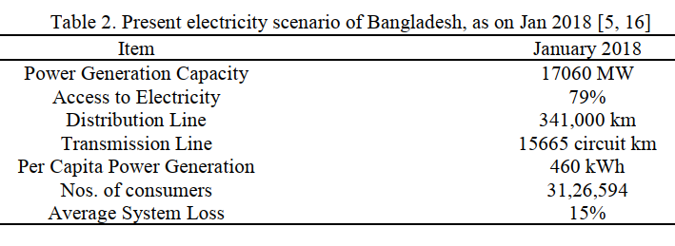

Table 2: Present electricity scenario of Bangladesh, as on Jan 2018

This table shows the electricity scenario of Bangladesh on January 2018. a current scenario of power sector of Bangladesh is given below in pie chart:

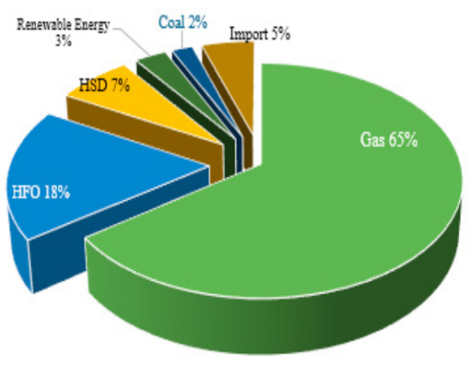

This pie chart shows the energy consumption by fuel type natural gas 63 %, heavy fuel oil 18%, high speed diesel 7%, power import 5%, coal 2% and Renewable energy 3%, with 9200 km transmission Lines, 332000 km distribution lines and 10% growth of electricity in the year of 2016[4].

# Present situation of renewable resources in Bangladesh

Bangladesh shares a level of environmentally friendly power just 3% of all out-energy proportion, Bangladesh has effectively taken an all-inclusive strategy in the environmentally friendly power area. Renewable energy technologies offer important benefits  
compared to those of conventional energy sources [5].  
Renewable energy resources are abundant; worldwide, 1000  
times more energy reaches the surface of the earth from  
the sun than is released today by all fossil fuels consumed. Though introduced power age introduced limit of Bangladesh quickly expanded to 13265 MW with hostage age limit which is deficient for satisfying the interest of power of the countries. One third of the power production of Bangladesh relies upon costly imported petroleum derivative energy assets and 65% of force age relies upon a flammable gas save of the country, however one day the save of current gas will be decreased. In addition, insufficient power creation drives the country in an un-industrialization. the present and future significant energy emergency circumstance adjusted by introducing inexhaustible force into power creation. The current sustainable power plan of Bangladeshi government power the specialization of sustainable power age spending plan by diminishing worldwide contamination with saving development of biomass, sunlight based, hydro, wind and tidal power sector.

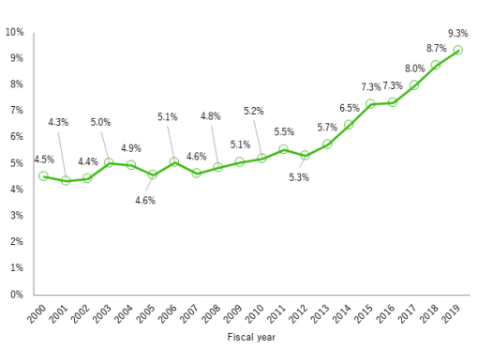

Fig 1.1: Renewable energy shares on overall energy rate [5]

# wind energy

Enormous measure of green energy is produced by wind energy. As we as a whole realize what energy is created by wind is called wind energy. Wind turbines, similar to windmills, are mounted on a pinnacle to catch the most energy. At 100 feet (30 meters) or more over-the-ground, they can exploit the quicker and less fierce breeze. Turbines get the breeze's energy with their propeller-like edges. Typically, a few cutting edges are mounted on a shaft to frame a rotor. An edge acts similar as a plane wing. At the point when the breeze blows, a pocket of low-pressure air structures on the downwind side of the sharp edge. The low-pressure air pocket at that point pulls the cutting edge toward it, making the rotor turn. This is called lift. The power of the lift is in reality a lot more grounded than the breeze's power against the front side of the sharp edge, which is called drag. The blend of lift and drag makes the rotor turn like a propeller, and the turning shaft turns a generator to make power.

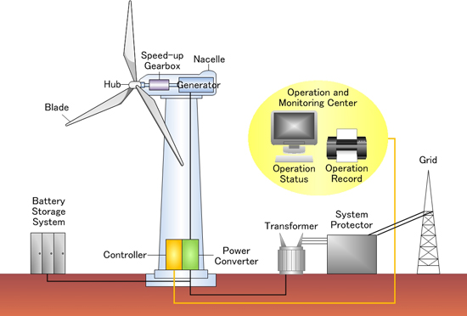

Fig 1.2: Wind based power generation process [6]

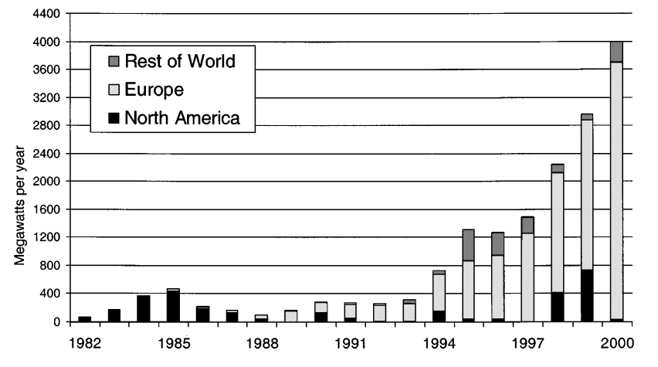

Fig: worldwide installation share of wind

The world is going on quick in the area of wind sustainable power and a turbine is utilized to change over wind energy into power. Bangladesh created 900 KW wind power at Muhuri Dam space of Sonagazi in Feni and 1000 KW Wind Battery Hybrid Power Plant at Kutubdia Island; Grameen Shakti, Bangladesh Center for Advanced Studies (BCAS), BRAC, Bangladesh Army, IFRD, Installed complete 19.2 KW at various beach front areas of Bangladesh. Be that as it may, Bangladesh has a world longest seaside belt of around 724 km in the line of Bay of Bengal and charge from wind turbines in Bangladesh need more techno-financial evaluation. Anyway, BPDB as of late recognized 22 locales for wind power age and inland Wind Power Plants along the coastline of waterfront areas of Bangladesh, besides BPDB has arranged a 50-200 MW wind ages plants Anawara around there, 15 MW Wind Power Plant in Muhuri Dam Area of Feni, Mognamaghat of Cox's Bazar, Parky Beach of Anwara in Chittagong, Kepupara of Borguna and Kuakata of Patuakhali.

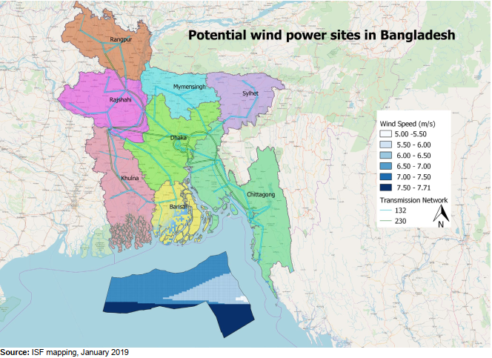

Fig: On- and offshore wind energy generation potential in Bangladesh[7]

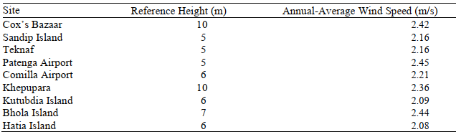

Fig 1.3: Wind energy potential in Bangladesh

# geothermal energy

Geothermal energy, type of energy change in which heat energy from inside earth is caught and tackled for cooking, washing, space warming, electrical force age, and other uses. Geothermal energy is a very powerful and efficient way to extract renewable energy from the earth through natural processes. This can be performed on a small scale to provide heat for a residential unit or on a very large scale for energy production through a geothermal power plant. It is cost effective, reliable and environmentally friendly but it has previously been geographically limited to areas near tectonic plate boundaries. Heat from Earth’s interior generates surface phenomena such as lava flows, geysers, fumaroles, hot springs, and mud pots. The warmth is delivered basically by the radioactive rot of potassium, thorium, and uranium in Earth's hull and mantle and furthermore by contact produced along the edges of mainland plates. The ensuing yearly poor-quality warmth stream to the surface midpoints somewhere in the range of 50 and 70 milliwatts (mW) per square meter around the world. Conversely, approaching sunlight-based radiation striking Earth's surface gives 342 watts for each square meter every year (see sun powered energy). Geothermal warmth energy can be recuperated and abused for human use, and it is accessible anyplace on Earth's surface. The assessed energy that can be recuperated and used on a superficial level is 4.5 × 106 exajoules, or about 1.4 × 106 terawatt-years, which compares to around multiple times the world's yearly utilization of a wide range of energy. The measure of usable energy from geothermal sources shifts with profundity and by extraction strategy. The increment in temperature of rocks and different materials underground midpoints 20–30 °C (36–54 °F) per kilometer (0.6 mile) profundity worldwide in the upper piece of the lithosphere, and this pace of increment is a lot higher in a large portion of Earth's known geothermal zones. Typically, heat extraction requires a liquid (or steam) to carry the energy to the surface. Finding and creating geothermal assets can be testing. This is particularly valid for the high-temperature assets required for creating power. Such assets are regularly restricted to parts of the world described by late volcanic action or situated along plate limits or inside crustal problem areas. Despite the fact that there is a ceaseless wellspring of warmth inside Earth, the extraction pace of the warmed liquids and steam can surpass the renewal rate, and, consequently, utilization of the asset should be overseen economically.

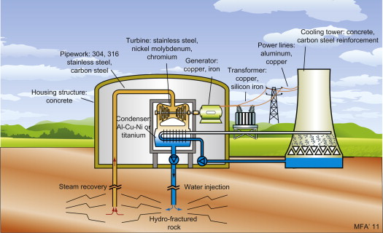

Fig 1.4: Geothermal energy-based power plant

Geothermal power is practical, solid, reasonable, and harmless to the ecosystem, however has truly been restricted to territories close structural plate limits. Later innovative advances have significantly extended the reach and size of feasible assets, particularly for applications like home warming, opening a potential inescapable abuse. Geothermal wells discharge ozone harming substances caught profound inside the Earth, however these outflows are a lot of lower for every energy unit than those of petroleum product. Bangladesh has a chance to create energy from geothermal sources and she has a local geothermal inclination from south-east district 19.8 to 29.5°C/km along the north-west 20.8 to 48.7°C/km with 110-153°C from 304 kilometers inside the earth. In any case, Rangpur Saddle (700m profundity form), Madhupur Clay (20 m) Single, Kuchma and Bogra (60-125 km) and Thakurgaon warm water locale are the primary wellsprings of geothermal energy. Bangladesh government have as of now plan to set up geothermal 200 MW power plant in Thakurgaon in collaboration with Anglo MGH.

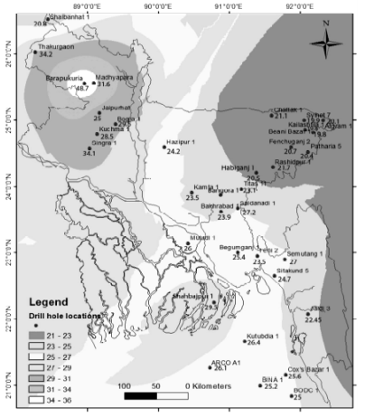

Fig1.5: Geothermal gradient of individual well

# COMPARATIVE ANALYSIS of wind and geothermal energy

There are tremendous prospects in Bangladesh, with sustainable renewable sources in various areas. Bangladesh has huge costal area which is very much suitable for wind-based power plant and in these type of plants on fuel is required. That wind-based power generation wind turbine is very mush suitable for our country’s perspective. Also, we have a large geometrical inclination from south-east district along the north-west side of our country. This type of geothermal based power is much eco friendly by considering other power generation systems. Also, geothermal energy asset is accessible agreeing to some geologist. So, in our countries perspective this geothermal based renewable is mush suitable for us. As we all know all types of thermal power plant need external fuel to produce energy but in geothermal power plant there is no need for any external fuel for production of electricity. Also, as we compare it to other power plant it requires minimum land space as compared to other plants. As we have geothermal fields available in our country, we can easily produce enough electricity from this kind of power plants. Only if we mange the cost of infrastructure and drilling, we can produce electricity more cost efficiently. So as consider all those facts geothermal based power plants are much suitable for our countries. A future forecast of average annual change in installed power plant capacity is given in table 1.5:

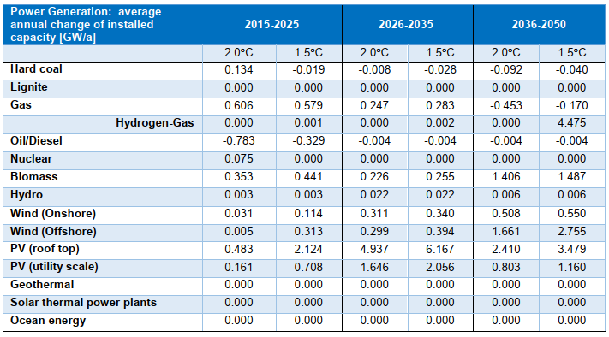

Fig 1.5: Average annual change in installed power plant capacity

# solution for increasing renewable share

In the present point of view renewable power sector has 3% share in our public network. By introducing geothermal and wind-based power plant in our national grid, we can build the offer presentence into 10%. Likewise, government had passed a rule that each new development building ought to introduce a solar system on the housetop around there. By installing on-grid this solar panel the presentence will be increasing. In the event that we can bear the introduce cost of this efficient power energy, we can undoubtedly profit through those frameworks. By this way the renewable offer rate will be 10 % in 2025.Hence, in renewable based power sector have to be introduce in total 1912 MW power plant. The acquainted matrix associated need with introduce all the more nearly furthermore, 1000MW wind power plant and the leftover 45 MW need to be made with geothermal asset. In this way, educated that in 2025 concerning 10% of sustainable power offer can conceivable in Bangladesh.

# Conclusion

In Bangladesh, the demonstrated saved of gaseous petrol 34 TCF which will lead the country next 20 years and presently 82% flammable gas devoured in the force area for power creation. While just 3% power created from green power sources. Notwithstanding, Bangladesh government have effectively reported an end-all strategy for future power age through the interest for power developing quicker rate. Subsequently, this system underlines the nations common asset investigation and revelations for additional improvement of the force area and recreate the renewables energy asset. In any case, to satisfy the not-so-distant future need Bangladesh needs more refined examination offices and gifted labor for investigation exercises both inland and seaward regions. The public authority should work with worldwide cutting-edge innovation utilizing human erudite people of the country for energy supportability. Environmentally friendly power can be considered as a likely option in contrast to ordinary energy that comes from petroleum product. Presently, there is a massive interest in the utilization of sustainable power like sun based, biofuel, geothermal, wind because of ecological and monetary concern. Bangladesh is a developing country. To generate the required power based on the high population it is not cost effective. In this case the easiest way to generate power is to use natural resource of our own country and it will be cost effective and it will be lifelong project. The public authority of Bangladesh has invested critical energy and focus to build up various tasks on environmentally friendly power which likewise sponsored by the public authority.

# acknowledgement

I am generously grateful to my honorable faculty S.M. IMRAT RAHMAN and only because of his consolation, oversight and guidance from the starter to the finishing up level empowered us to build up a comprehension of the subject.

##### References

1. *Geothermal energy and its scope in Bangladesh*. (2014). <https://doi.org/10.1109/ICDRET.2014.6861684>
2. M.R. Islam, P.C. Sarker, S.K.J.R. Ghosh, S.E. Reviews, Prospect and advancement of solar irrigation in Bangladesh: A review, 77 (2017) 406-422.
3. E.D. Vance, P.C. Brookes, D.S.J.S.b. Jenkinson, Biochemistry, An extraction method for measuring soil microbial biomass C, 19 (1987) 703-707
4. Z. Tan, H. Zhang, J. Xu, J. Wang, C. Yu, J.J.J.o.E.E. Zhang, Photovoltaic power generation in China: Development potential, benefits of energy conservation and emission reduction, 138 (2011) 73-86
5. K. Elissa, “Title of paper if known,”unpublished <www.mpemr.gov.bd/>
6. Wind energy outlook 2000. Amer. Wind Energy Assoc. [Online].Available:<http://www.awea.org/outlook2000/index.html>
7. <www.uts.edu.au/sites/default/files/201908/Bangladesh%20Report-2019-8-17.pdf>
8. N.G.M.J.G. BPDB, Bangladesh Power Development Board, 88 (2010) 3.76.
9. B.R. Scanlon, B.L. Ruddell, P.M. Reed, R.I. Hook, C. Zheng, V.C. Tidwell, S.J.W.R.R. Siebert, the food‐ energy‐ water nexus: Transforming science for society, 53 (2017) 3550-3556
10. <https://www.google.com/search?q=Comparison+between+the+prospect+of+Geothermal+and+Wind+energy+in+Bangladesh&oq=Comparison+between+the+prospect+of+Geothermal+and+Wind+energy+in+Bangladesh&aqs=chrome..69i57.1401j0j7&sourceid=chrome&ie=UTF-8>